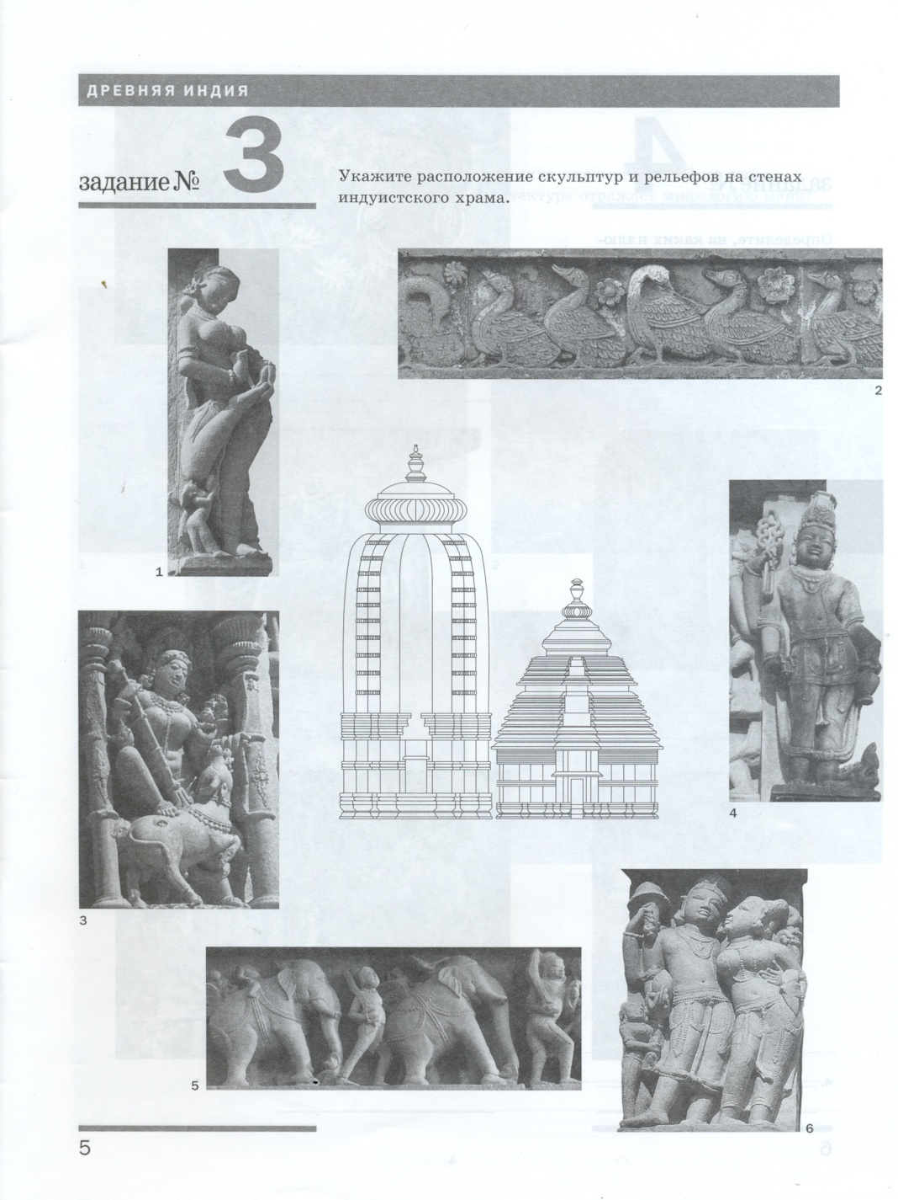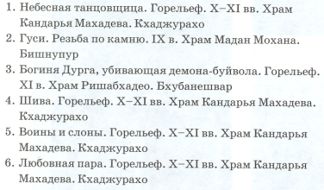 ФИО __________________________________  ФИО __________________________________